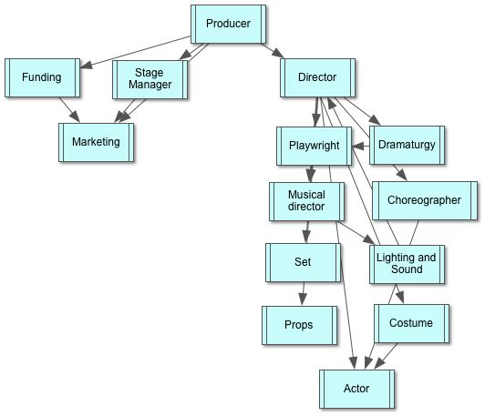

Producer
I. Stage Manager
II. Director
A. Playwright
B. Dramaturgy
C. Choreographer
D. Musical director
1. Lighting and Sound
E. Set
F. Props
G. Costume
H. Actor
III. Funding
IV. Marketing

