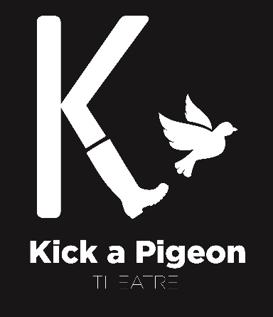
Market Analysis, Market Strategy and Action Plan
Kick a Pigeon Theatre: ‘Record ‘97’
Performance: 24th May 2017
Completed by Kimberley Bowe - Marketing Manager

- WHO ARE WE
  - Company Summary
Kick a Pigeon Theatre are a collective of students currently studying Drama at the University of Lincoln.

Founded in 2017, the group came together through their shared love of comedy and reminiscing about the “good ol’ days” with one goal in mind – to create side-splittingly funny shows with a nostalgic twist.

Through the combination of old news, new writings, borrowed tunes and some (not so) blue scenarios, the group aims to create theatre that snaps your heartstrings, fractures your funny bones and smashes that box of memories from decades past.

  - UNIQUE SELLING POINT

We bring light comedy to serious events that occurred in the 1990s.
We have researched into the entire decade and selected elements which we feel will portray the 1990’s in the best possible way.
Kick A Pigeon Theatre are driven to create high quality theatre which puts a different twist on contemporary theatre.
Record ’97 will allow the audience to transport themselves into the world of the 90s with the use of live music, audience interaction and the odd bottle of wine.

  - WHAT IS HAPPENING AROUND US
In-House competitors –
Fragment Theatre Company
Rubbish Theatre
Like Comment Share
The Pin Hinge Collective
Backpack Ensemble

Other Local Competitors –
The Engine Shed
Lincoln Drill Hall
Lincoln Theatre Royal
Odeon Cinema

  - Strengths, Weakness, Opportunities, Threats (SWOT)

STRENGTHS  New upcoming theatre company  10 artists with different skill sets and different ideas for the productions.  In house marketing and technical staff  £166 budget  Studio space available for rehearsals | WEAKNESSES  A new theatre company who are unknown/ no reputation  Small budget to put on a large scale show  Competing with other upcoming theatre companies  Contradicting ideas with the team members  Other commitments within the group
OPPORTUNITIES  Work with versatile indivuduals who all have their own ideas  Free studio space available in the venue.  Audience members who know the venue will return.  To learn new strengths from different members of the company | THREATS  Company members prioritising other engagements  Need to fundraise due to small budget  Competitors marketing strategies being more successful  Contradicting ideas

  - SWOT Summary
Kick A Pigeon Theatre aim to create a production of a high standard taking into consideration the marketing strategies needed in order to attract our target audience. Marketing will work with the needs of the audience in order to make attractive advertisements to get the attention of old and new audiences.

- TARGET AUDIENCES

  - TARGET AUDIENCE PROFILE
This performance is applicable to an audience aged 16+ due to the use of strong language.
Our target audience include:
- Performing Arts students
- People interested in comedy.
- People interesting in the 1990s.
- Friends and families of the performers.
- Local societies.

  - KEY MESSAGES
- It will be a professionally produced production
- A show fit for people to reminisce about the 1990s
- Include a pre-show full of audience interaction
- One off experience to see a production featuring eight graduating drama students.

- UNDERSTANDING THE MARKET

  - MARKETING TOOLS

Who? | What? | How?
Friends and Family | Social Media  Word of Mouth | Inviting Friends and Family to like and share the social media pages. Update the pages regularly with information regarding the company.  Talk to everyone about the Theatre Company, focusing mainly on engaging those who would enjoy the performance.
City Residents | Posters  Flyers | Put posters up in shops and cafes/restaurants to attract attention for potential audiences.  Talk to the locals and give them an insight into the company and hand out advertisements to the locals who are approached.
Other Local Companies
Students | Social Media  Direct E-mail | Create online competitions, update the websites regularly and attract new audiences.  Email round tutors and course co-ordinators to tell arts students about the upcoming performance.

